**Objective –**

Write a program to implement Bubble Sort.

**Description –**

**Bubble Sort**

* **It**  is a simple algorithm which is used to sort a given set of n elements provided in form of an array with n number of elements. Bubble Sort compares all the element one by one and sort them based on their values.
* If the given array has to be sorted in ascending order, then bubble sort will start by comparing the first element of the array with the second element, if the first element is greater than the second element, it will **swap** both the elements, and then move on to compare the second and the third element, and so on.
* If we have total n elements, then we need to repeat this process for n-1 times.
* It is known as **bubble sort**, because with every complete iteration the largest element in the given array, bubbles up towards the last place or the highest index, just like a water bubble rises up to the water surface.
* Sorting takes place by stepping through all the elements one-by-one and comparing it with the adjacent element and swapping them if required.
* This algorithm is not suitable for large data sets as its average and worst case complexity are of Ο(n2) where **n** is the number of items.

## Algorithm

We assume **list** is an array of **n** elements. We further assume that **swap** function swaps the values of the given array elements.

begin BubbleSort(list)

for all elements of list

if list[i] > list[i+1]

swap(list[i], list[i+1])

end if

end for

return list

end BubbleSort

Program –

#include<stdio.h> // header file

#include<conio.h>

void bubbleSort(int arr[], int n) // function declaration

{

int i, j, temp;

for(i = 0; i < n; i++) // for loop

{

for(j = 0; j < n-i-1; j++) // nested for loop

{

if( arr[j] > arr[j+1]) // if statement

{

// swap the elements

temp = arr[j];

arr[j] = arr[j+1];

arr[j+1] = temp;

}

}

}

// print the sorted array

printf("Sorted Array: ");

for(i = 0; i < n; i++)

{

printf("%d ", arr[i]);

}

}

int main()

{

Clrscr();

int arr[50], i, n, step, temp;

// ask user for number of elements to be sorted

printf("Enter the number of elements to be sorted: ");

scanf("%d", &n);

// input elements if the array

for(i = 0; i < n; i++)

{

printf("Enter element no. %d: ", i+1);

scanf("%d", &arr[i]);

}

// call the function bubbleSort

bubbleSort(arr, n);

return 0;

}

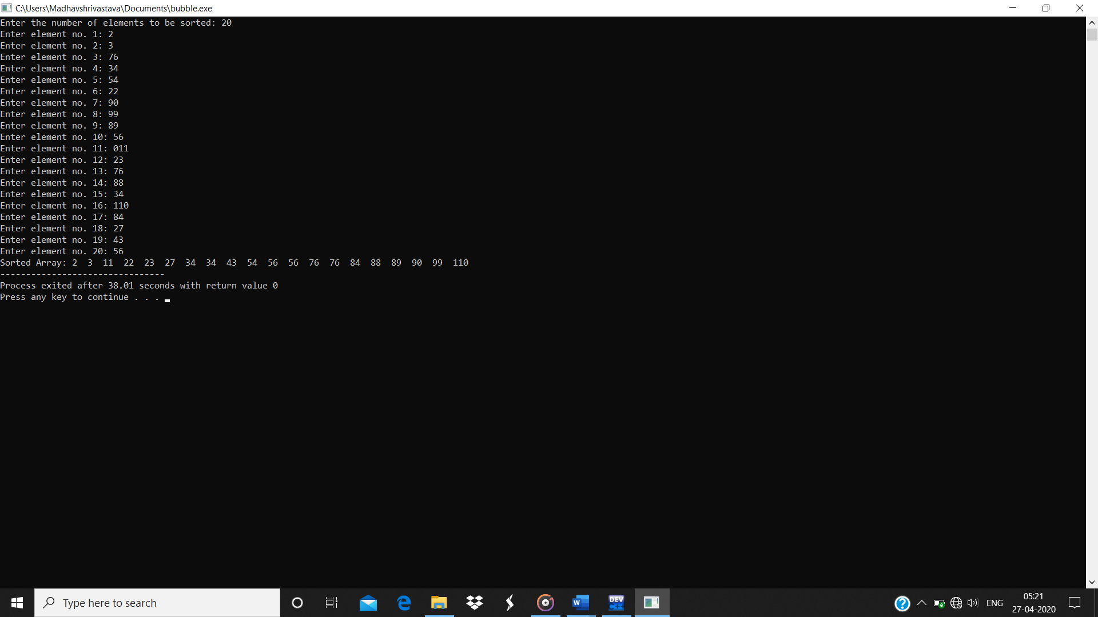Output :-